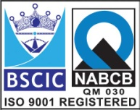****

**SAFETY & THERMAL RELIEF VALVE (Model: AEW-ES-101)**

High Performance Safe & Reliable

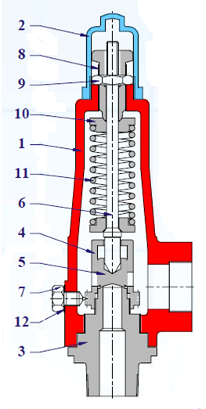 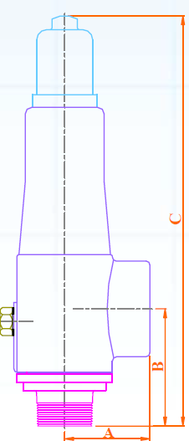

**Features: -**

* Model : AEW-ES-101
* Spring: Spring Steel Zn. Plated
* End Connection: BSP Screwed
* Rating: 150# / 300#
* Leak Tight Sealing

**Design Standard:- API-520**

**Testing Standard:- API-527**

**Part List With Material Specification:- Dimension Table:-**

|  |  |  |  |  |  |  |  |  |
| --- | --- | --- | --- | --- | --- | --- | --- | --- |
| **No.** | **Part Name** | **Materials** |  | **Size** | **A +-3.0** | **B+-3.0** | **C+-5.0** | **Weight** |
| 01 | Body | ASTM A216 Gr. WCB  ASTM A351 Gr. CF8/CF8M |  | 15x25 | 55 | 92 | 265 | 3 |
| 02 | Cap |  | 20x25 | 55 | 92 | 265 | 3 |
| 03 | Nozzle | ASTM A351 Gr. CF8/CF8M |  | 25x25 | 55 | 92 | 265 | 3 |
| 04 | Nozzle Ring |  | 40x50 | 68 | 95 | 325 | 5.5 |
| 05 | Disc | SS 304/ SS316 / Soft Seated |  | 50x50 | 68 | 95 | 325 | 5.5 |
| 06 | Stem | SS 304/ SS316 |  |  |  |  |  |  |
| 07 | Lock Screw | MS/ SS 304/ SS316 |  |  |  |  |  |  |
| 08 | Adjusting Screw | MS/ SS 304/ SS316 |  |  |  |  |  |  |
| 09 | Adju. Screw Nut | MS/ SS 304/ SS316 |  |  |  |  |  |  |
| 10 | Spring Washer | MS/CS/SS304/SS316 |  |  |  |  |  |  |
| 11 | Spring | Spring Steel (Ni. Plated) |  |  |  |  |  |  |
| 12 | Gasket | CAF/ Graphite/PTFE |  |  |  |  |  |  |

**Due to continuous development Program, the design & data given in this leaflet are subject to change without prior notice.**

**ANITA ENGINEERING WORKS**



58-59, Narayan Estate, Opp. Shree Ram Estate, Nr. CMC Ltd. Odhav, Ahmedabad-382415, Gujarat, India

Phone: +91 79 22974101, Fax: +91 79 22875014

Email: eascovalves@yahoo.com, eascovalves@gmail.com, Web: [www.eascovalve.com](http://www.eascovalve.com)